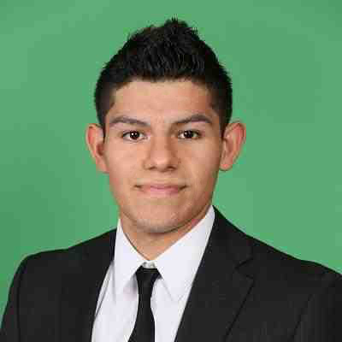Roberto Hernandez

**2962 N Bend Dr. Dallas, TX 75229**

**214 455 3712**

[**roberto2.hernandez@citi.com**](mailto:roberto2.hernandez@citi.com)

**EDUCATION**: Southern Methodist University May 2016

Bachelor of Arts in Creative Computation

GPA: 3/4.0

**TECHNICAL SKILLS:**

Netinfo, AWS, Chef, Pinnacle, Service Now, Java, HTML, Javascript, Ruby, Python, C++, Swift, ARM, C#, PowerShell, Node.js, MS Access, SQL, MS Excel, MS Office, Adobe Products, Jira, Maya, AutoCad, Unity3D, 3D printing

**EXPERIENCE:**

**CTI Analyst May 2017 - June 2018**

**Network Telecommunications**

* Connected circuits to devices and reported changes
* Verified circuits to reduce discrepancies in the databases
* Worked with vendor management to validate 3rd party troubleshooting

**CTI Analyst June 2016 - March 2017**

**Cloud Infrastructure**

* Developed cookbooks for nodes that installed patches or services
* Automated the process of uploading and checking cookbooks to Chef servers
* Learned Ruby and Python for Chef infrastructure

**IT Intern at Liberty Mutual Insurance, Seattle USA May 2015 - August 2015**

**IT Program Manager in Personal Insurance**

* Program Manager of various projects in the Personal Insurance IT field
* Organized server and queue data for my team in a weekly PowerPoint
* Built web pages and integrated data

**Web Developer at SMU, Dallas USA August 2014 - 2016**

**Assistant Developer**

* Test the school website and debug it
* Update content and layouts
* Assist in developing the page using HTML and JavaScript
* Make website responsive

**LEADERSHIP AND PROJECTS:**

* Circuit Discrepencies (decreased cross-connect discrepancies from Netinfo and Connectivity Manager)
* Analyst Project LATAM lead (gathered LATAM alerts’ information running a script on the DL to export to excel)
* CITI Lean Apprentice Certificate
* CITI Hack-a-thon (developed logic for the EMIEW robot)